1. **Analysis**
   1. **Motivation**

Recommendation system, a subpart of the information filtering system, helps users in making optimal choice by refining the data, based on user’s preferences. System filters the data and provides useful information to the users and when this information comes in the form of suggestion the system is called recommender system. Presently recommender system has become a popular tool and has been used in many types of applications such as Facebook, Twitter, Youtube.com, Amazon.com, MovieLen etc.

The topic of our project is to design and the implement a recommendation system for suggesting users the movies of their preferences of the genre and the recently visited links of the user. The main objective of our system is to provide an attractive user interface which helps the user to select the user of his interest.

* 1. **Problem Definition**

Owing to the various demerits of pure content-based and pure CF based systems, we have proposed a hybrid recommender system which is known as content-boosted collaborative filtering system. This hybrid system takes advantage from both the representation of the content as well as the similarities among users. The intuition behind this technique is to use a content-based predictor to fill the user-rating matrix that is sparsely distributed. The dataset consists of a user-rating matrix. Content-based predictions are used to train each user-rating vector in the user-rating matrix and convert it into a pseudo rating matrix which combines actual rating with the predicted ratings. Collaborative filtering is then applied to this full pseudo user-rating matrix to make recommendation for an active user.

* 1. **Scope**

A hybrid approach is taken between context based filtering and collaborative filtering to implement the system. This approach overcomes drawbacks of each individual algorithm and improves the performance of the system. Techniques like Clustering, Similarity and Classification are used to get better recommendations thus reducing MAE and increasing precision and accuracy. In future we can work on hybrid recommender using clustering and similarity for better performance. Our approach can be further extended to other domains to recommend songs, video, venue, news, books, tourism and e-commerce sites, etc.

1. **Planning**
   1. Sitemap/ Navigation

HOME

Search

Login in

Contact us

Feedback

About us

Web structure

Sign up

Fig: 2.1.1 – Sitemap for the website.

* 1. **Computing environment**

**Software Requirements:-**

|  |  |  |
| --- | --- | --- |
| **Front-End** | **Back-End** | **Tools** |
| **Languages**   * HTML5 * CSS4 * JavaScript * Bootstrap * Python | **Languages**   * PHP * JavaScript   **Databases**   * PHPmyadmin | * GoJS * Jupyter notebook * Windows 10 * Web browser-Google Chrome * Sublime text * XAMPP * Internet Connection installation of web frameworks |

**Fig: 2.2.1 – Software requirements for the project**

**Hardware Requirements:**

* Laptop / PC

1. Intel core i5 processor
2. 4 GB RAM
3. 1 TB Hard-disk
   1. **Project implementation schedule**

|  |  |  |  |  |
| --- | --- | --- | --- | --- |
| Sr No. | Task name | Duration | Start | Finish |
| 1 | Selecting the topic for the project. | 7 days | 23-07-2018 | 30-07-2018 |
| 2 | Planning the site and its layouts. | 3 days | 31-07-2018 | 02-08-2018 |
| 3 | Researching ML algorithms suitable for Recommendation. | 10 days | 03-08-2018 | 12-08-2018 |
| 4 | Researching for a Web structured UI and finding GoJS for the same. | 15 days | 13-08-2018 | 27-08-2018 |
| 5 | UI for Login, Sign Up and Main page. | 7 days | 28-08-2018 | 04-09-2018 |
| 6 | Understanding GoJS and manipulating it. | 10 days | 05-09-2018 | 14-09-2018 |
| 7 | Designing the database | 1 day | 15-09-2018 | 15-09-2018 |
| 8 | Filling the Database. | 1 day | 16-09-2018 | 16-09-2018 |
| 9 | Implementing the ML algorithm in python | 12 days | 17-09-2018 | 29-09-2018 |
| 10 | Merging it with our website | 5 days | 30-09-2018 | 04-10-2018 |
| 11 | Testing | 5 days | 05-10-2018 | 09-10-2018 |
| 12 | Documentation | 10 days | 10-10-2018 | 19-10-2018 |

**Fig: 2.3.1 – Timeline of the project.**

1. **Design**
   1. **Construction and Design** 
      1. **Designing site structure**

We designed our website in Linear site structure which helps the user to move in a sequence.

* + 1. **Navigation**

As soon as the Home page opens the user is given options in the navbar as to where to go. On clicking on the About tab he will be directed to the about page giving information about the website. The next tab is the Contact Us page giving the user the liberty to ask queries related to the site. The feedback page is provided to the user to let him provide us with suggestions as to what problems did he face or what are the things that can be enhanced in the website. The search icon redirects the user to the search page letting him search and get information about the searched movie. The sign up tab lets the user to create a new account and the login tab opens a pop up letting the user to log into the website.

* + 1. **Page layouts**

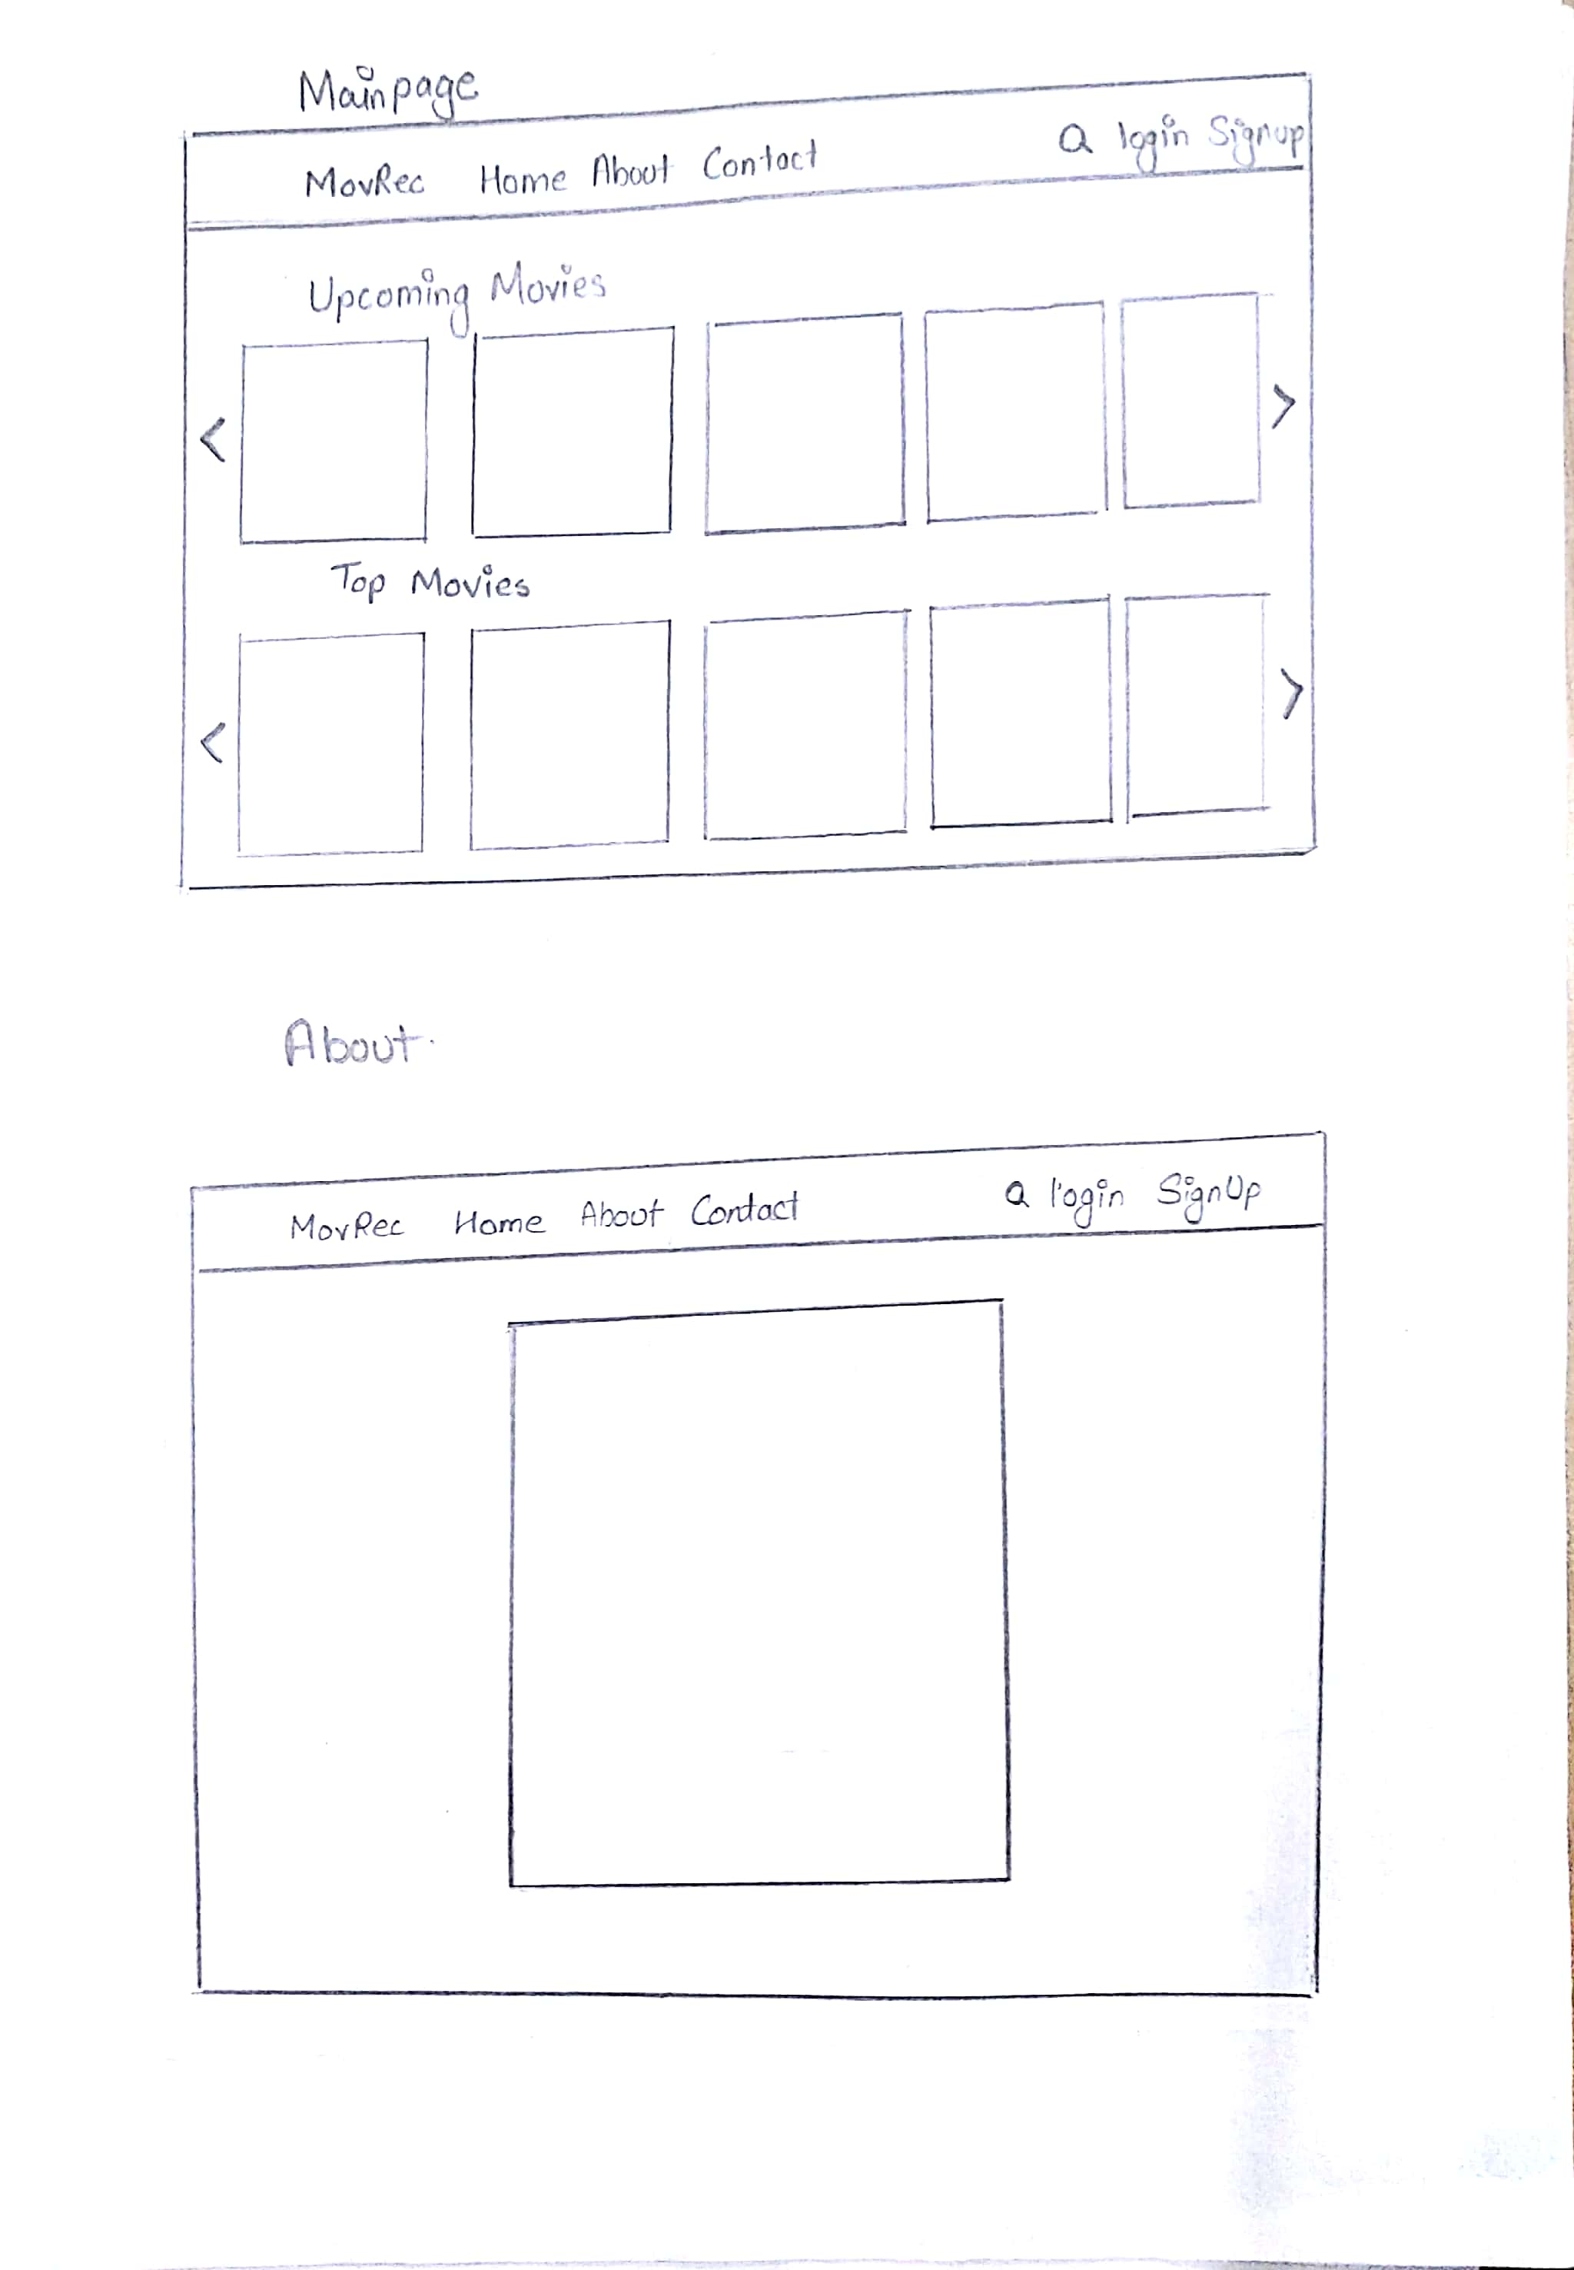

**Fig: 3.1.3.1– Main page**

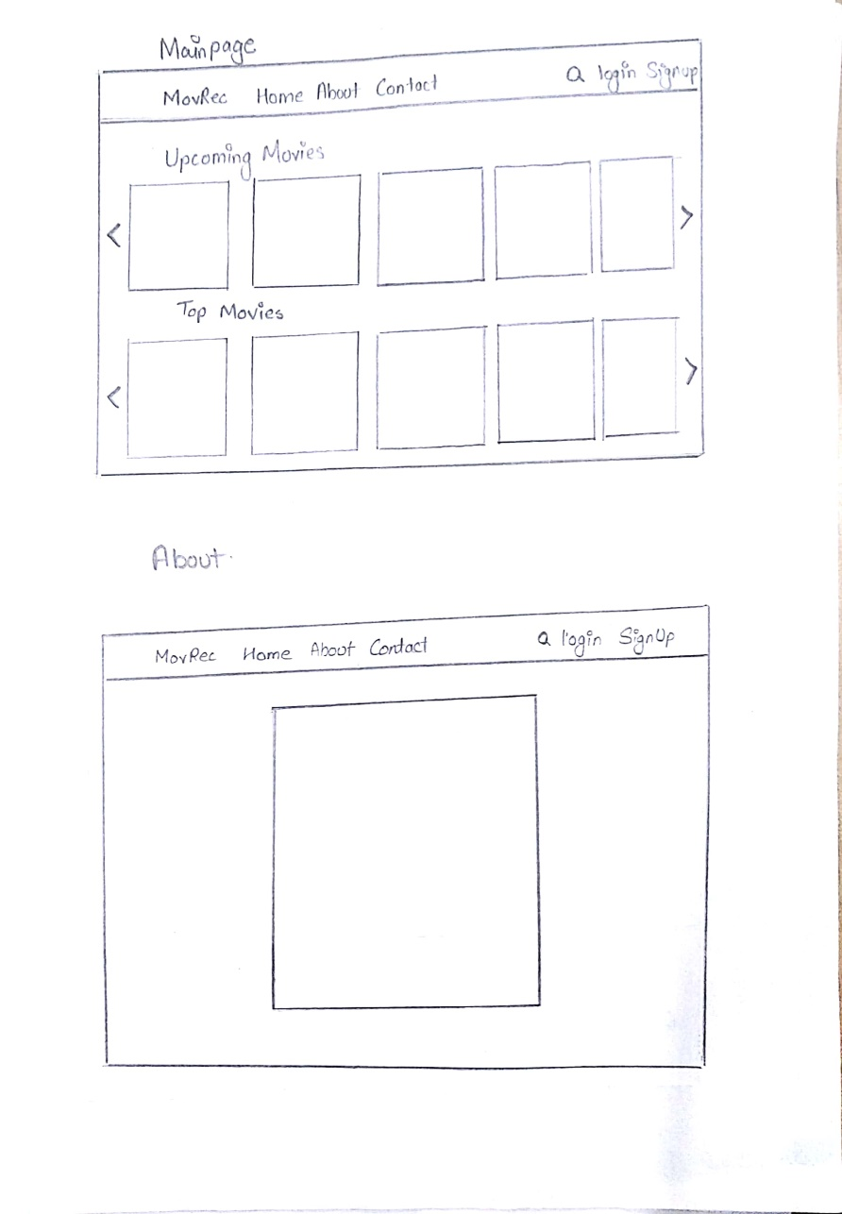

**Fig: 3.1.3.2 – About page.**

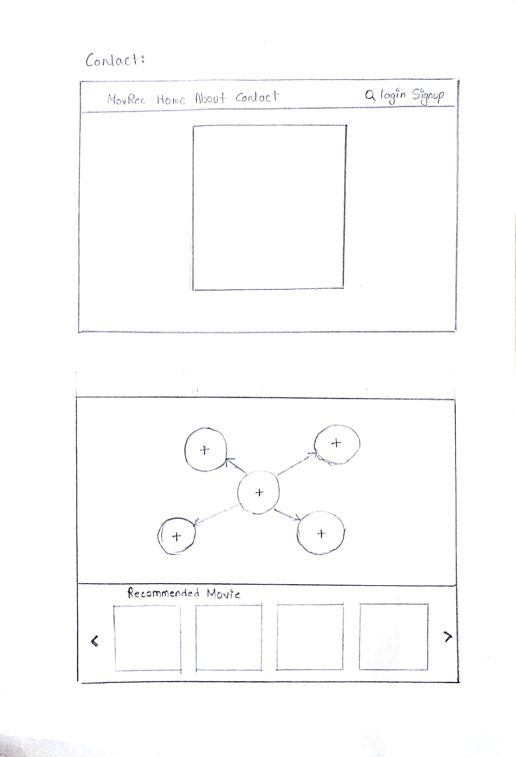

**Fig: 3.1.3.3 – Contact page**



**Fig: 3.1.3.4– Web Structure page**

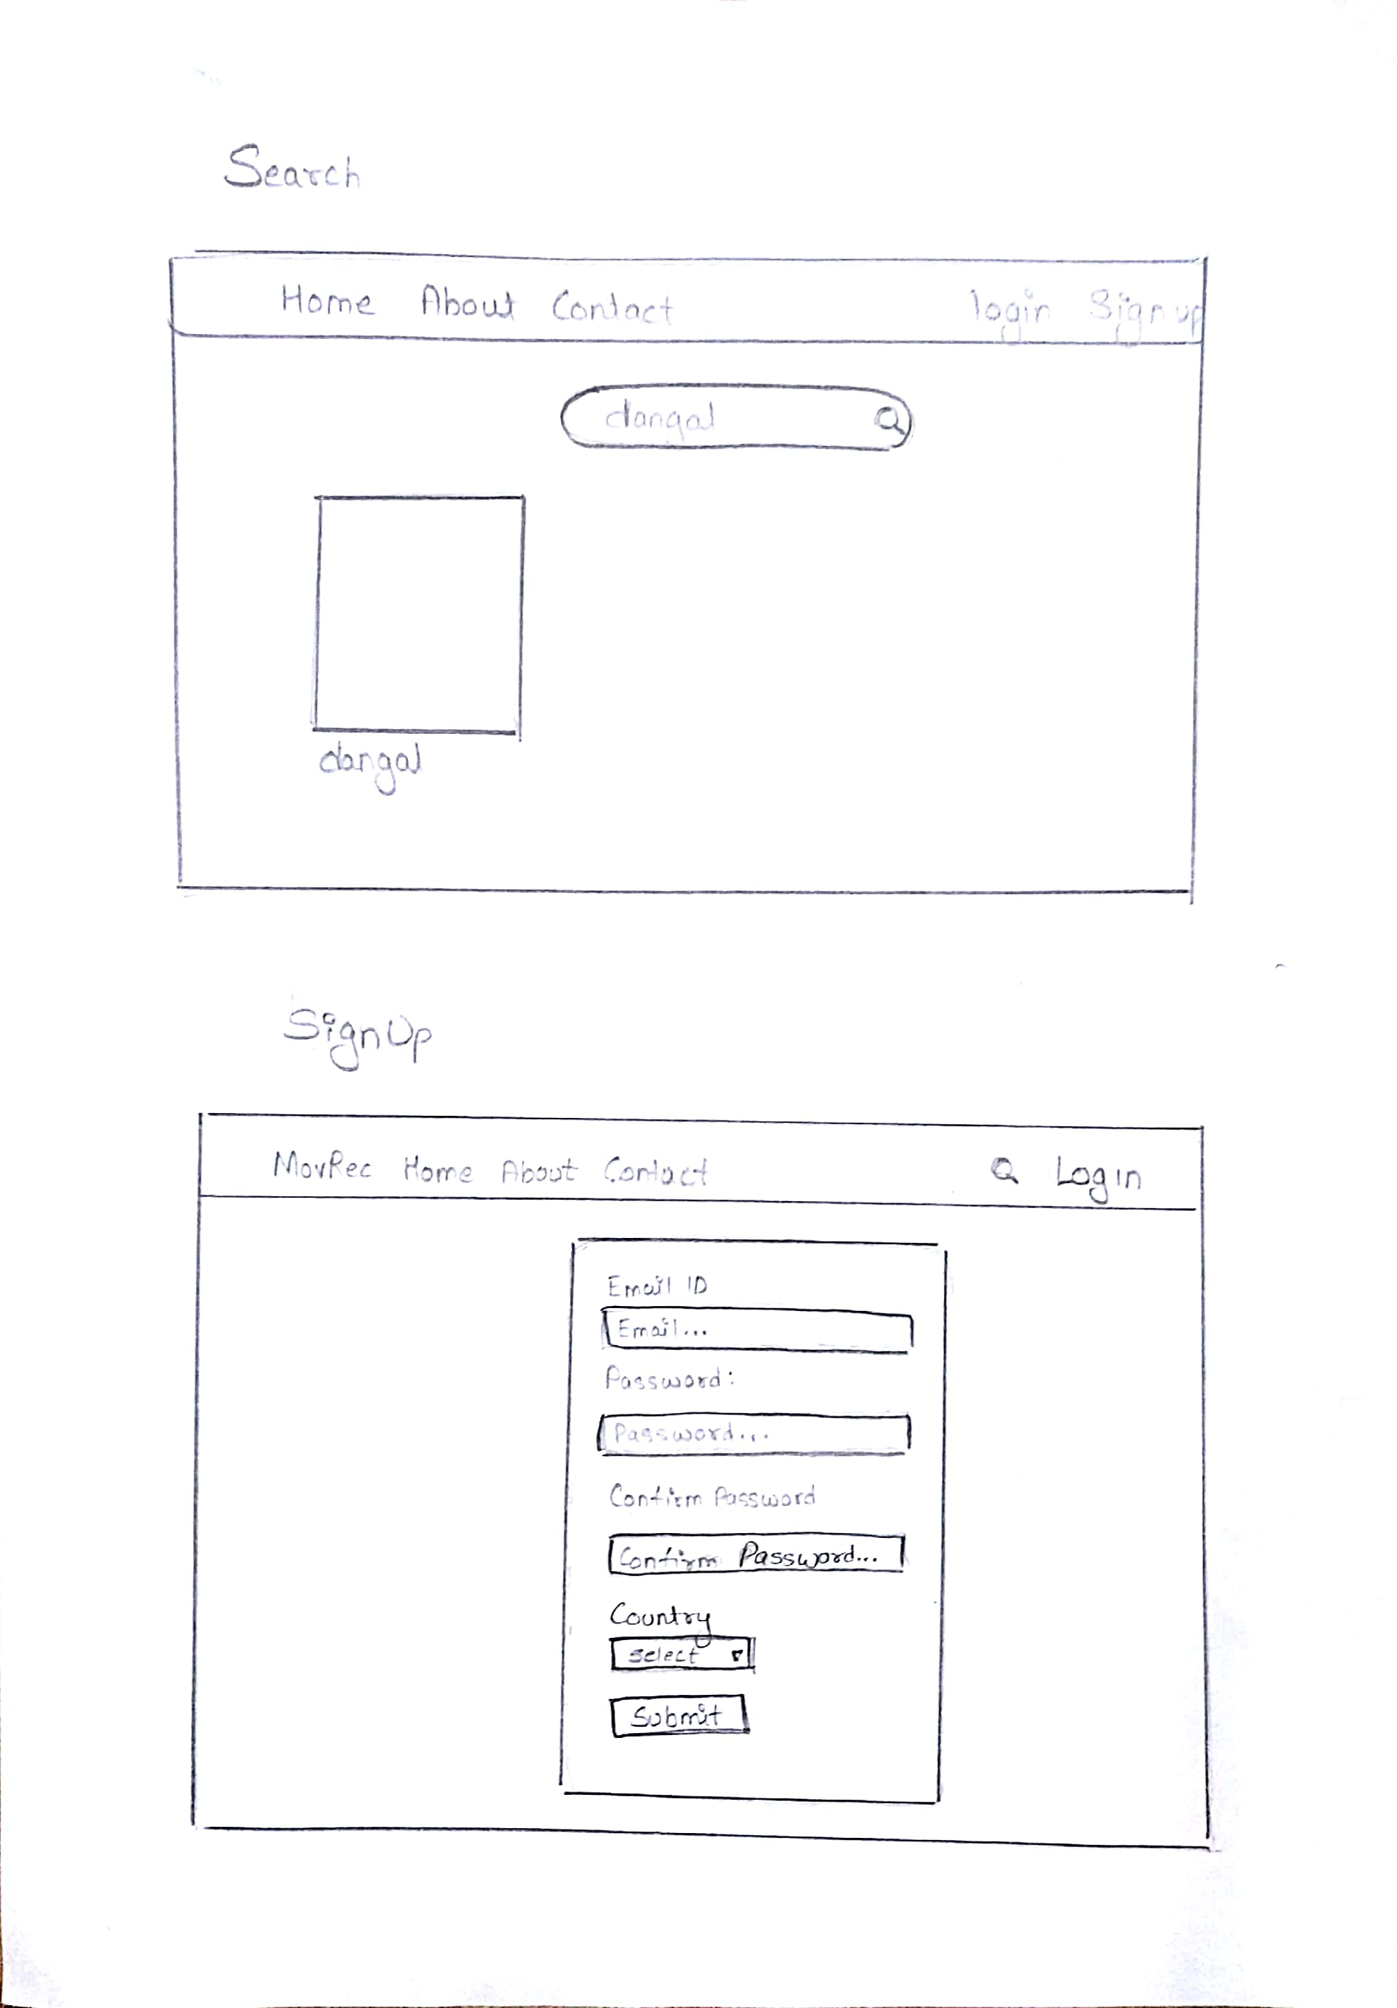

**Fig: 3.1.3.5– Search page**



**Fig: 3.1.3.6– Sign up page.**

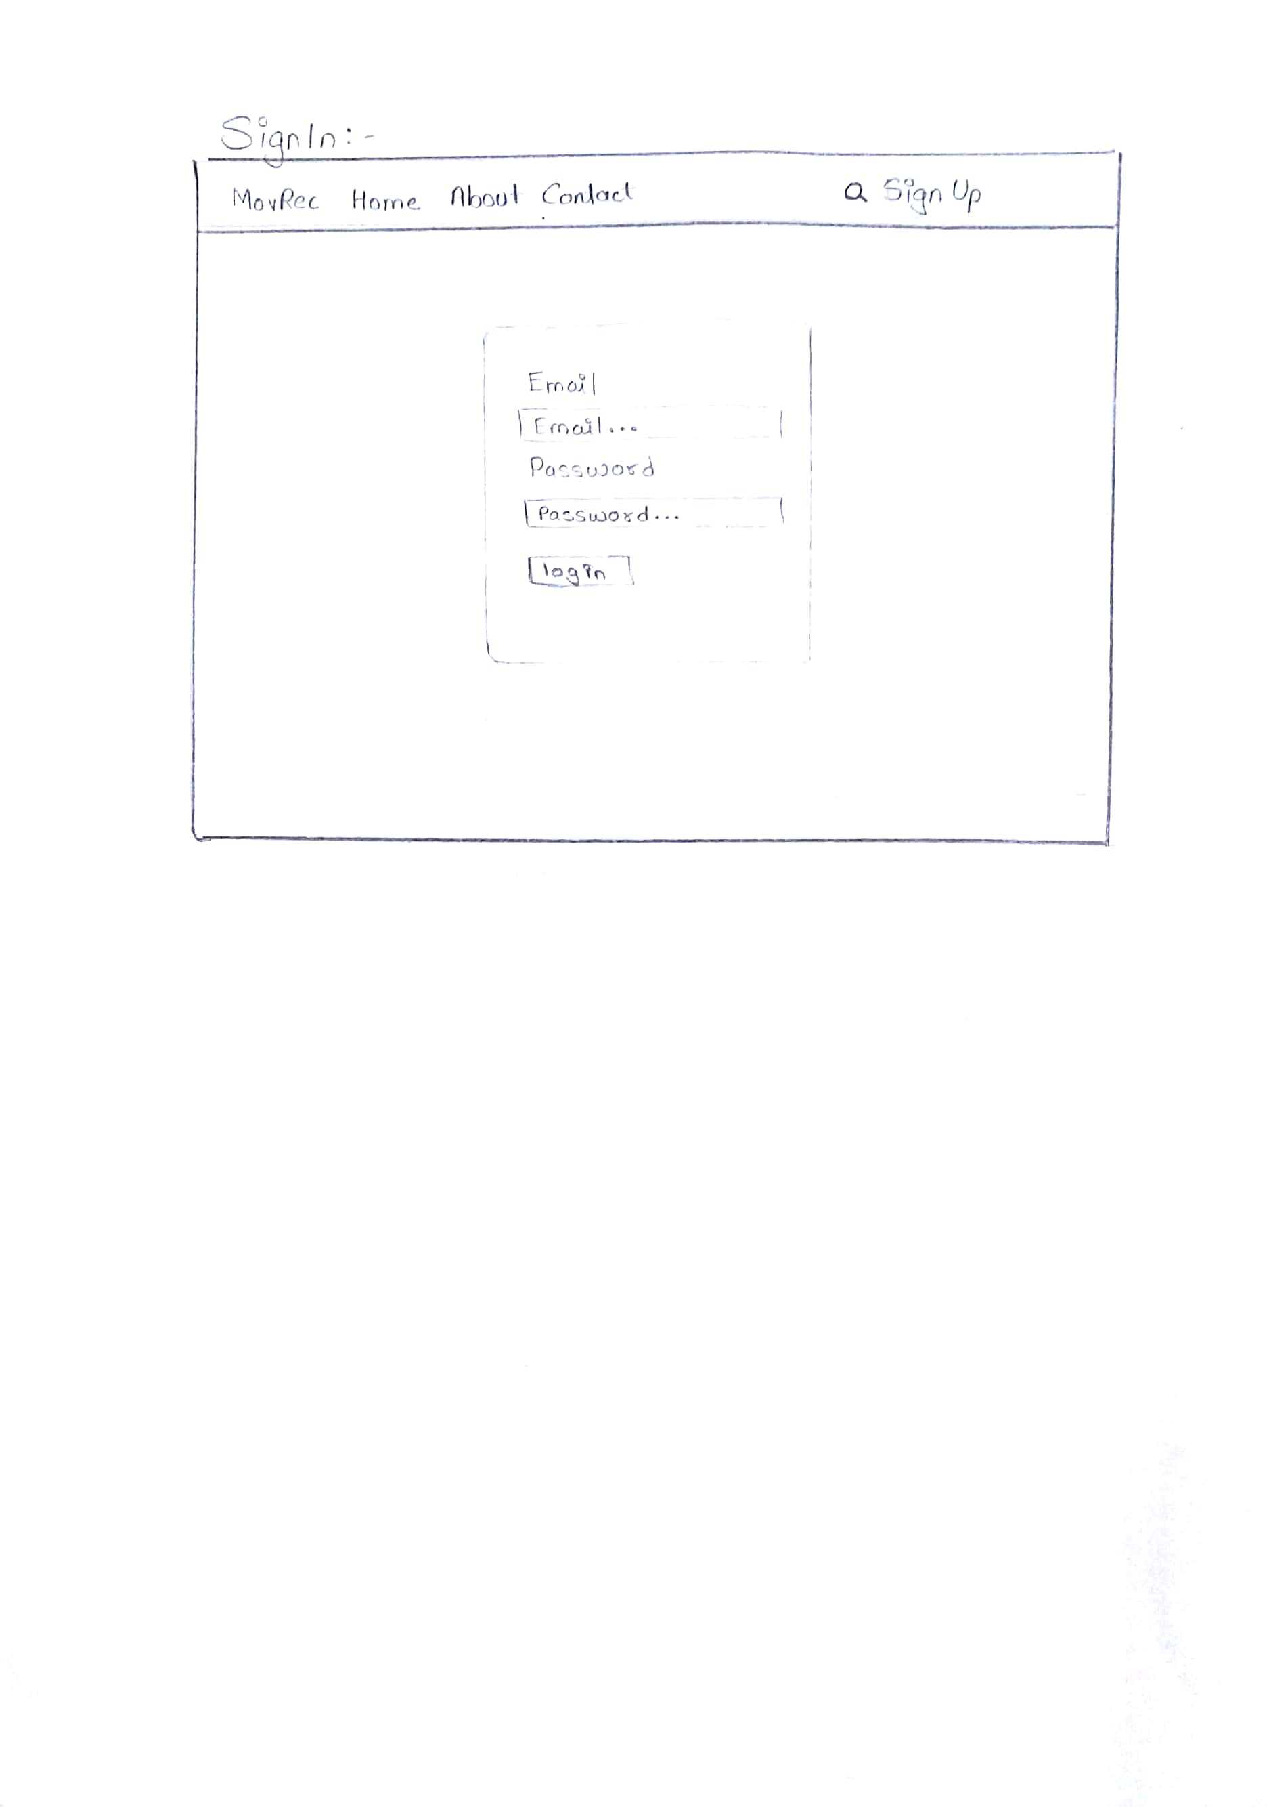

**Fig: 3.1.3.7– Log in page**

* + 1. **Database Design**

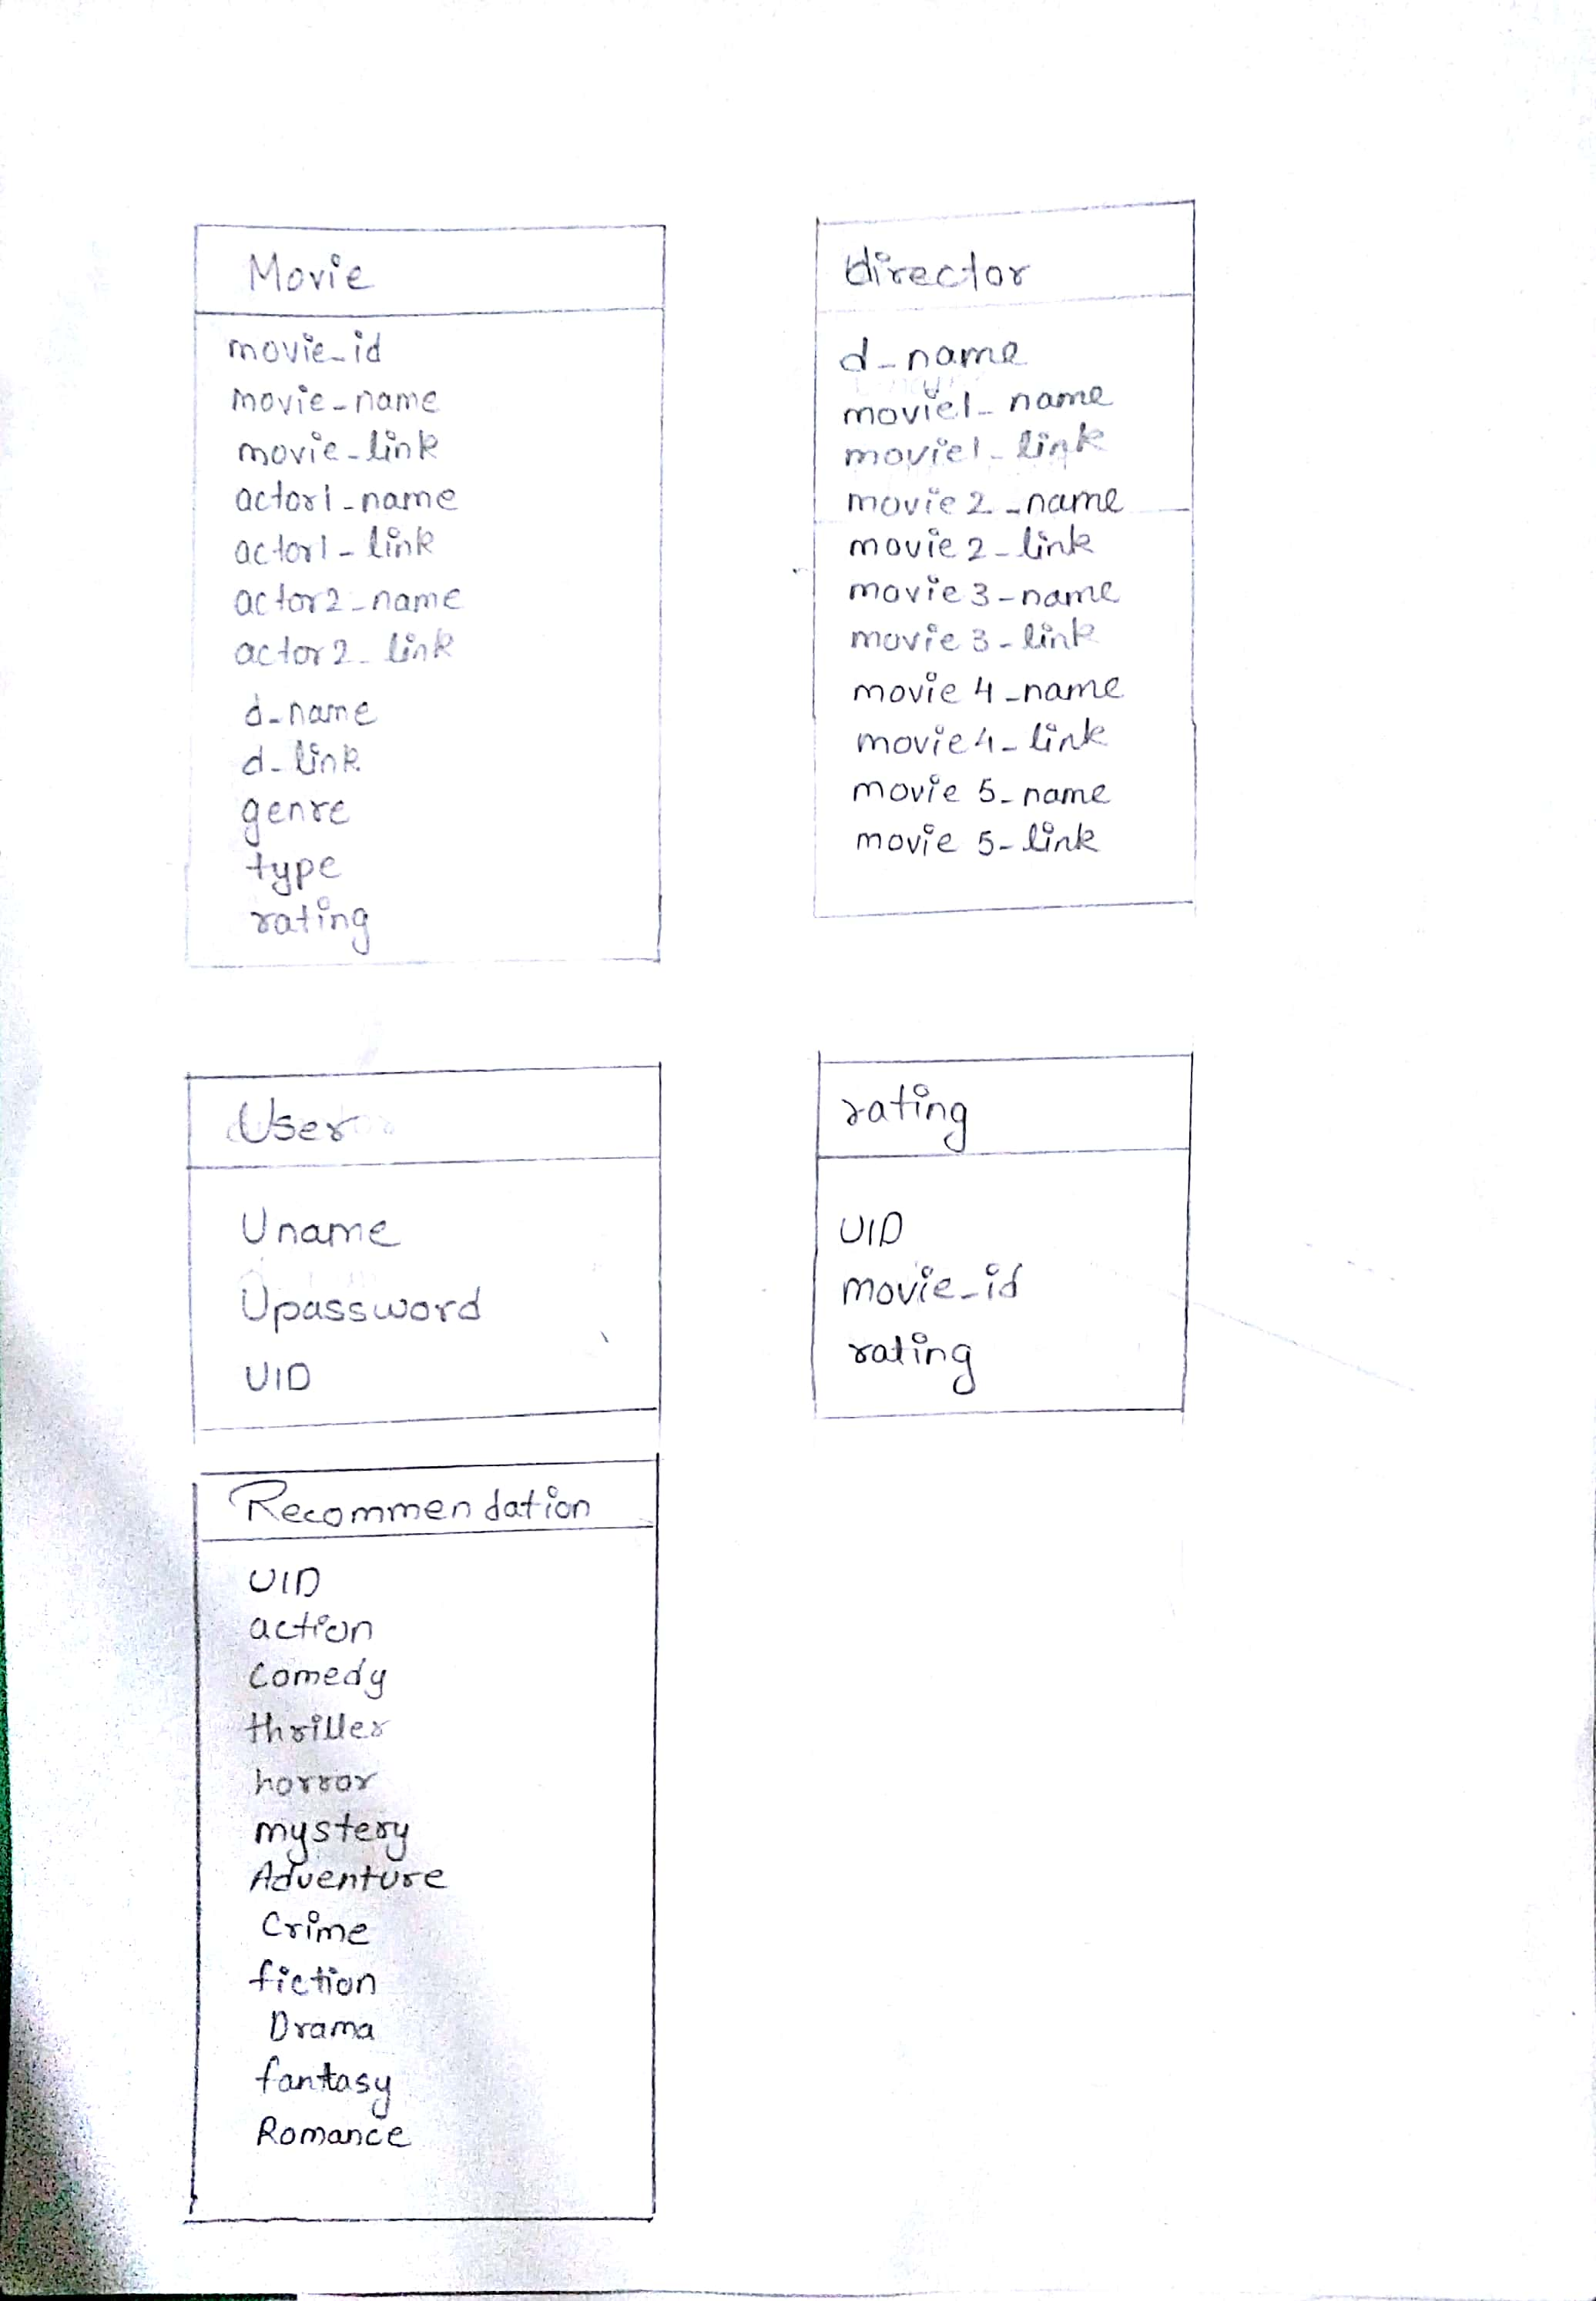

**Fig: 3.1.4.1 – Database Design.**

1. **Implementation**

Main page: It is the home page of MovRec which displays the upcoming and top movies to the user. The user can click on any of the movies and go to the next page i.e. web structure.php for further information.

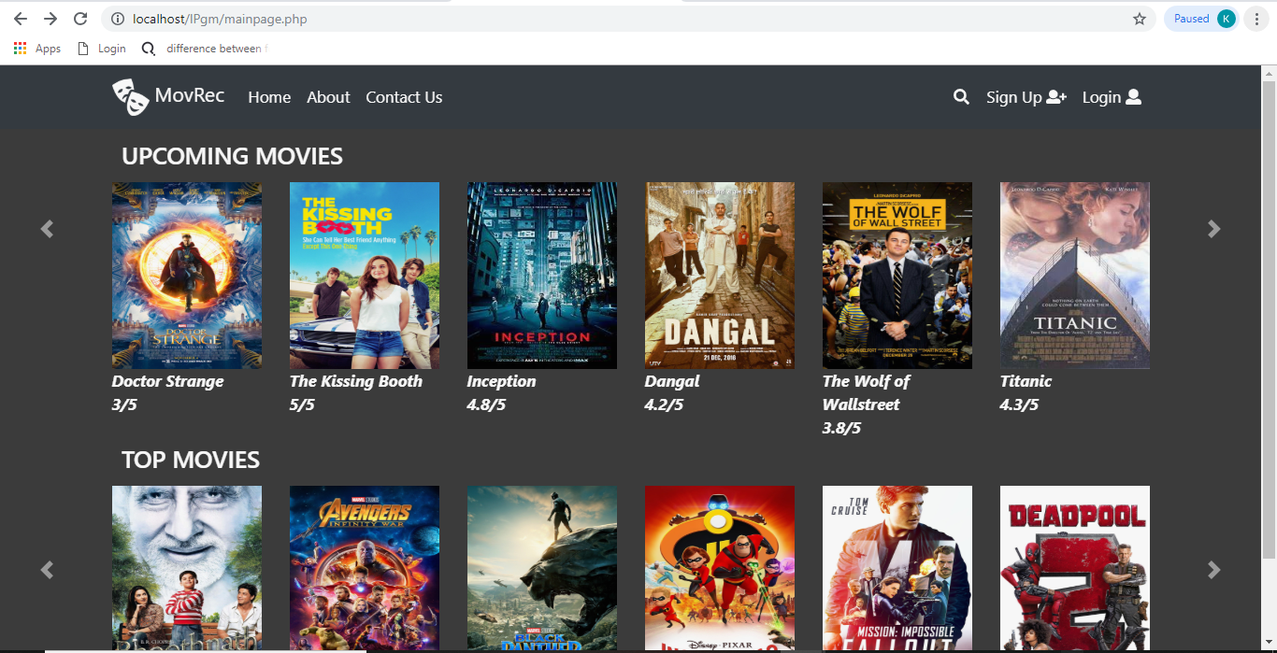

**Fig: 4.1 – Main page of the website.**

Web structure.php – This page is the full detailed information about the clicked movie i.e. it contains the lead actors, director and genre of the movie. On further clicks on the respective circles it shows related data. Example for director it shows the three movies that the director has made.

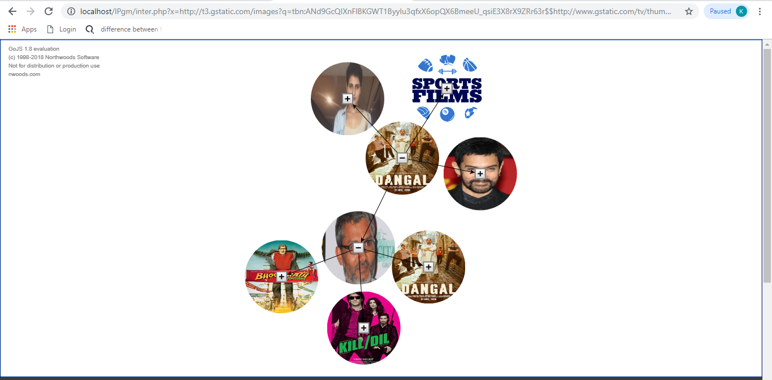

**Fig: 4.2 – Web structure page**

The same page has recommendations done to the user based on the genre and the movies that he has viewed before.

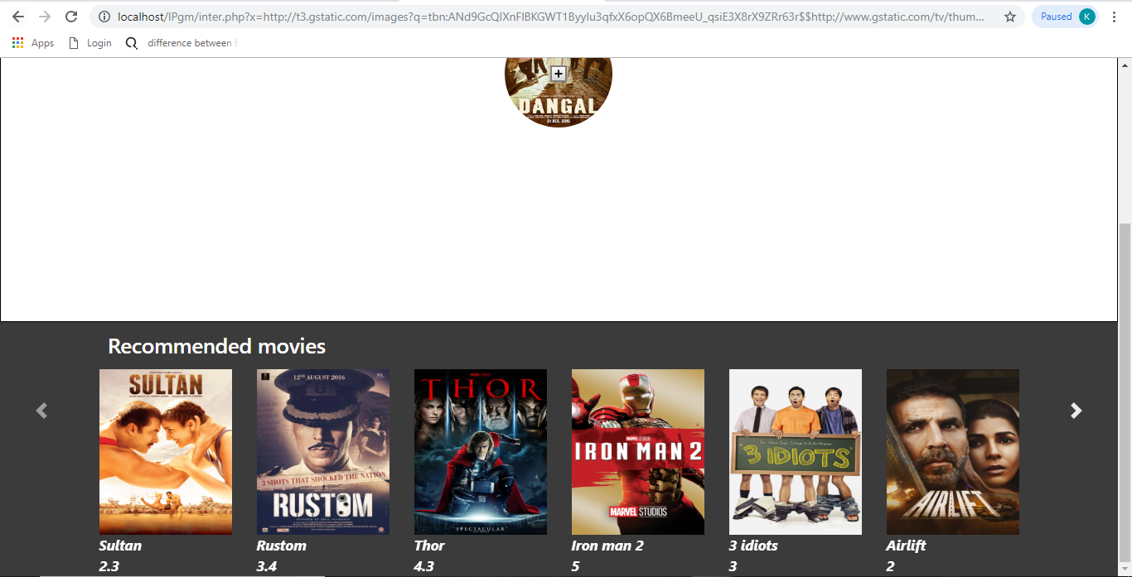

**Fig: 4.3 – Recommendation available to the user on Web structure page.**

Login (Main page): a pop up in the main page to log user into the site.

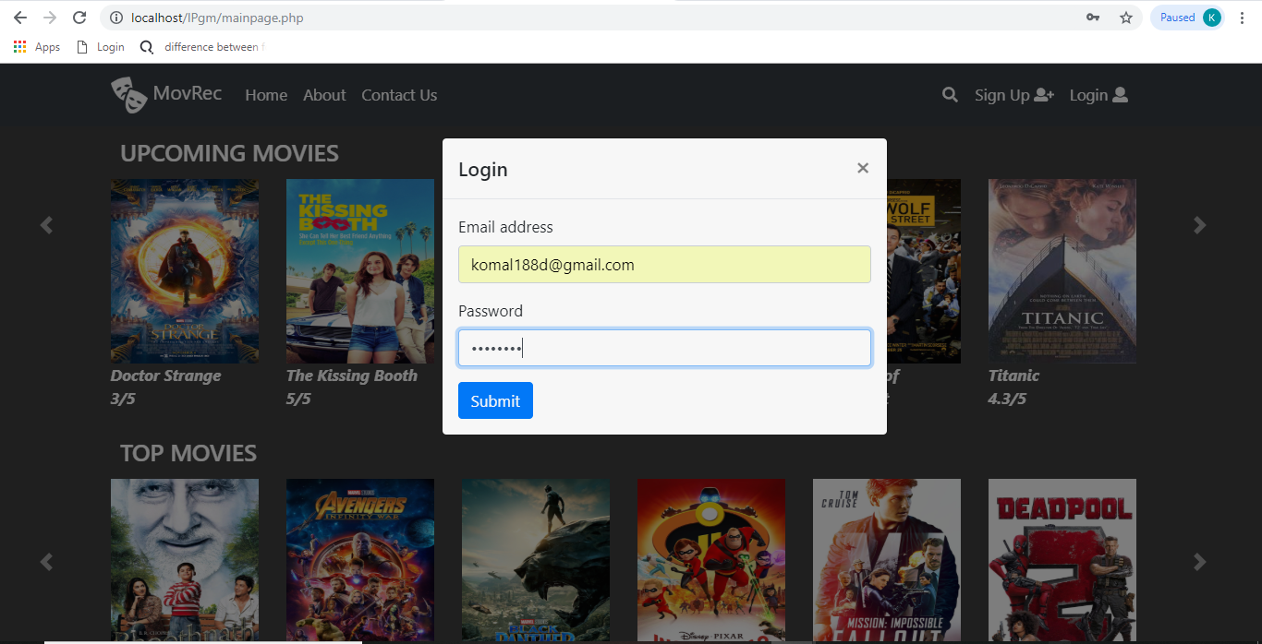

**Fig: 4.4 –Login modal on the Main page**

Login page: A new page to allow user to login if he is not on the main page.

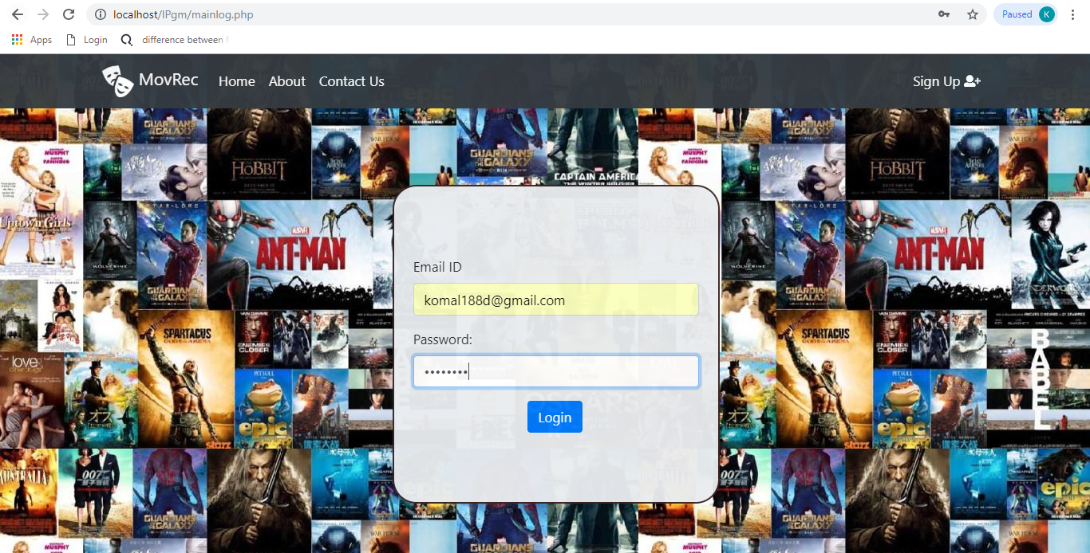

**Fig: 4.5 –Login page**

Sign up page: Lets the user create his account if he has not created an account yet.

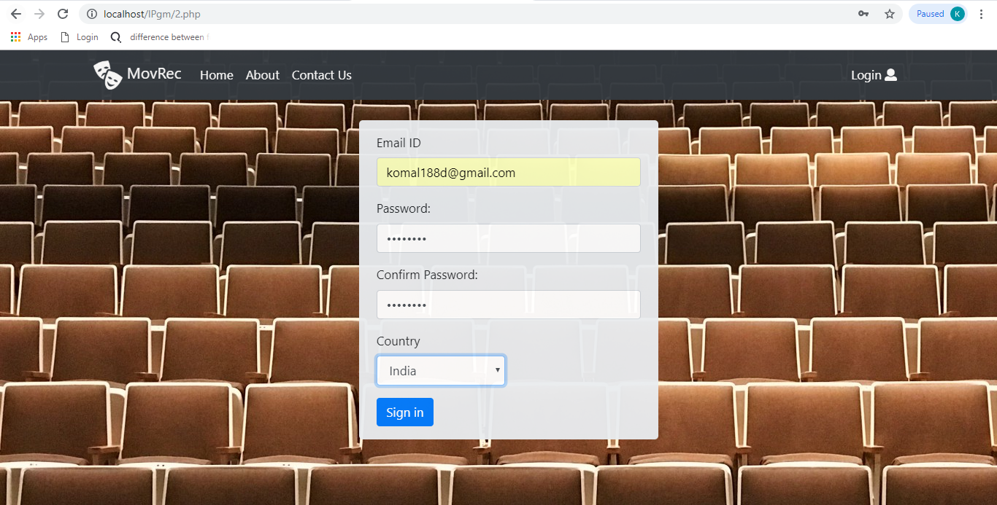

**Fig: 4.6 – Sign up page**

Search page: allows the user to search for a particular movie of his choice. If the movie is present it will display the movie on clicking which it can go to web structure.php. If not present it will display an error message.

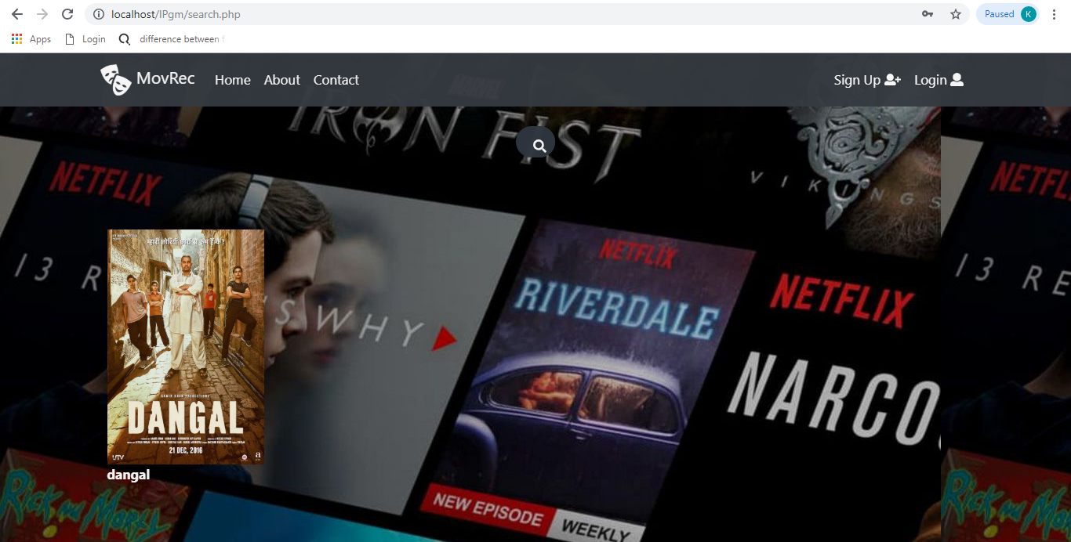

**Fig: 4.7 – Search page**

Contact us page: The ways in which a user can get in touch with us for queries related to login or signup or any other issue are displayed on this page.

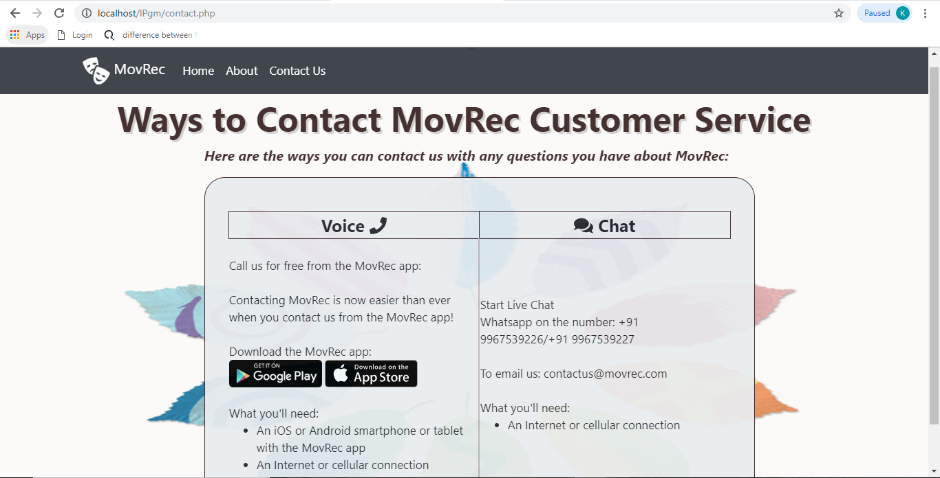

Fig: 4.8 –Contact Us page

About us page: Displays to the user the authenticity of the site and the creators of the website.

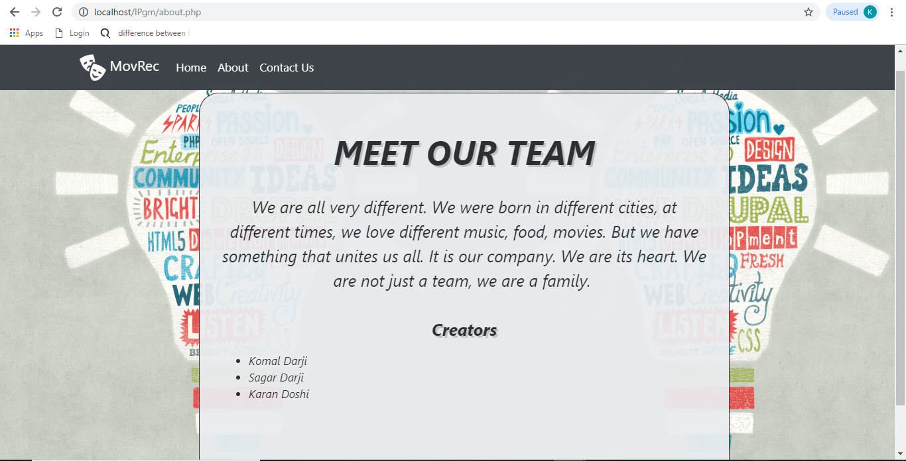

**Fig: 4.9 –About page**

1. **Testing and Deployment**

|  |  |  |  |  |
| --- | --- | --- | --- | --- |
| **Test Case ID** | **Test Case** | **Expected Output** | **Actual Output** | **Result** |
| 1 | Login Username and Password | Login Successful | Login Successful | Pass |
| 2 | Registration | Registration Successful | Registration Successful | Pass |
| 3 | Recommendation | Recommendation successful | Recommendation Successful | Pass |
| 4 | Path navigation | Path navigation successful | Path navigation successful | Pass |
| 5 | Database Integrity | Database Integrity successful | Database Integrity successful | Pass |
| 6 | Browser Compatibility | Browser Compatibility successful | Browser Compatibility successful | Pass |
| 7 | Logout | Logout Successful | Logout Successful | Pass |

**Fig: 5.1–Test cases.**

1. **Future Scope**

The attractive UI of our website enables the user understandibility and to go through the website with ease; the website can be expanded for TV shows and plays etc. For future there can be another module so as to book tickets for a particular movie, find available theatres nearby and also recommend theatres on the basis of the past selections made by the user. This will make the website a full-fledged movie recommendation and booking website. The user will be notified as and when the choice of his movie is about to release or has been released. The project is intended to serve as a foundation for a future, better optimised version that might be submitted on Google Play Store as well.

1. **References**
2. [**https://gojs.net/latest/index.html**](https://gojs.net/latest/index.html)
3. [**http://www.diva-portal.org/smash/get/diva2:1219240/FULLTEXT01.pdf**](http://www.diva-portal.org/smash/get/diva2:1219240/FULLTEXT01.pdf)
4. [**http://studentnet.cs.manchester.ac.uk/resources/library/3rd-year-projects/2015/dan.manoli.pdf**](http://studentnet.cs.manchester.ac.uk/resources/library/3rd-year-projects/2015/dan.manoli.pdf)
5. [**http://www.ijesrt.com/issues%20pdf%20file/Archive-2016/November-2016/63.pdf**](http://www.ijesrt.com/issues%20pdf%20file/Archive-2016/November-2016/63.pdf)
6. [**https://www.sciencedirect.com/science/article/pii/S1110866516300470**](https://www.sciencedirect.com/science/article/pii/S1110866516300470)
7. **https://www.researchgate.net/publication/308494000_A_Review_of_Latest_Web_Tools_and_Libraries_for_State-of-the-art_Visualization**